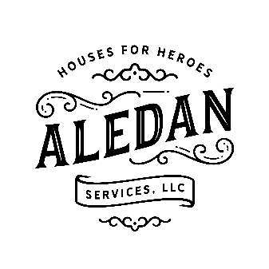
93 Rotterham Drive, Hedgesville, WV 25427 (304) 702-9955
“Putting Heroes in Home”

Date: ________________________

Brokerage Firm, License Number and MRIS CODE: _____________________________

Agent Name, License Number and MRIS CODE: ________________________________

Brokerage Firm Address and Phone Number:

_______________________________________________________________________

Broker’s Mobile Phone Number: ______________________________

Broker’s Email: ____________________________________________

I, ___________________________ (Broker’s Name) of _____________________ (Real Estate Brokerage Firm), listed above hereby agree to the release at Settlement 25% of ___________________ (Agent’s Name) portion of the commission to Aledan Services, LLC as a marketing fee for participation in the Heroes in Homes Program. The acknowledgement is agreed upon and enforceable for the duration (and automatically renews) of _____________________ (Agent’s name) membership in Aledan Services, LLC.

It is the broker’s responsibility to notify Aledan Services, LLC of any changes to primary broker status and/or any other changes which would effect or nullify this authorization. Thank you.

Broker’s Signature Date

